November 2026 Newsletter
Beautiful Savior Lutheran Church-LCMS
A Message from Pastor Schuldheisz -

October 31, 1517 - the hammer blow heard ‘round the world. On this date Martin Luther posted his famous 95 theses on the church door in Wittenberg, Germany. It was the 16th century version of Facebook and Twitter. If you had information you wanted people to read and discuss, that’s where you posted it.
But what drove Luther’s hammer that All Hallows Eve? It wasn’t fame and fortune. It was a simple question: How can a guilty sinner stand in the presence of a holy God? The church of Luther’s day had an answer: you can’t unless you made satisfaction for your sins. Luther worked hard, yet despaired. His good works were not enough to blot out his guilt. For Luther, finding forgiveness and salvation in the eyes of God was like climbing a never-ending ladder. And the church had an answer for this too. Buy an indulgence, a piece of paper which was sold to the people granting partial, and in some cases plenary (meaning full), remission of sins.
Problem is, when Luther searched the Scriptures for answers he didn’t find God’s forgiveness up for sale. That hammer blow of October 31, 1517 goes to the very heart of what the Reformation is all about. It answered Luther’s question: How can guilty sinners stand before a holy God? On the basis of works, merits, pieces of paper, coins, or anything we do? No. Never. Rather, salvation is a free gift by the grace of God through Christ’s death. On the cross, Jesus took your sin and gives you his righteousness. He took your death and gives you his life. It’s a blessed exchange.
That knock-knock of the hammer was the joyful proclamation of the Gospel breaking Luther’s despair. After Luther put the hammer away he picked up the pen and the Scriptures. He found in the pages of Scripture a Savior who rescues guilty sinners by being numbered with them. He found a merciful God who exchanged everything we have - sin, death, and guilt – for everything he has - holiness, eternal life, and righteousness. That was Luther’s comfort and it’s yours too.
For there’s something else that comes to mind when I hear the knock-knock of a hammer. Nails. Wood. Hands. Feet. Christ Crucified for you.
Jesus is your guarantee of eternal life. Jesus’ death for you. Jesus’ resurrection from the dead for you. So, do not fear. Christ bore your sin. Your guilt is covered. Your debt is paid in full. Death is destroyed. Rejoice in this good news.
And that’s what the Reformation is all about.

1
From Pastor & Family ~
Dear Saints of BSLC… Thank you all so much for your care and support of our family. Your kind words and thoughtful gifts during Pastor Appreciation Month deeply warm our hearts. You are a blessing to us as well. Thank you, and Christ’s Peace be with you all.

By Matthew C. Harrison
The story the world tells is not hopeful. Every day there’s something new to fear, some way your life is outside your control, some grave threat to your person or property, some variation of death. It’s easy to get caught up in the hand-wringing, to let our Christian hope be drowned out by the constant cacophony and chaos.
But we know a better story. Every November begins with the Feast of All Saints on Nov. 1. Every time I consider those who have preceded us in life, in faith and in death, I remember the words of the author of the Epistle to the Hebrews.
Therefore, since we are surrounded by so great a cloud of witnesses, let us also lay aside every weight, and sin which clings so closely, and let us run with endurance the race that is set before us, looking to Jesus, the founder and perfecter of our faith, who for the joy that was set before him endured the cross, despising the shame, and is seated at the right hand of the throne of God. (Heb. 12:1–2)
All our loved ones whom we rightly — but not hopelessly — grieve on All Saints’ Day still surround us. Jesus teaches that our guardian angels (Luther believed Matthew 18 teaches we all — not just children — have a guardian angel) protect us while beholding the face of our Father in heaven. So we sing “with angels and archangels and with all the company of heaven” as Christ comes to meet us and feed us with His body and blood. While they surround us, they do not distract us. Rather, like the crowds that swell as the finish line of a race approaches, they sharpen our focus on what lies ahead. So we fix our eyes on Jesus, who endured a shameful death on the cross, and whose victory over the grave guarantees our own bodily resurrection.

2
The end of our story is guaranteed. The Lord who endured death and triumphed over the grave, who in Baptism joined us into His very death and resurrection (Rom. 6:3–4; Col. 2:12; Titus 3), will not abandon us to the grave. We know the end of the story, which gives us courage to face the days between now and then.
Consider him who endured from sinners such hostility against himself, so that you may not grow weary or fainthearted. In your struggle against sin you have not yet resisted to the point of shedding your blood. (Heb. 12:3–4)

The Lord’s church is the original resistance movement. She has always resisted the hopelessness, faithlessness and lovelessness of a culture of death. Everything the Lord’s church does is founded on this resurrection courage. If nothing can change the future of those who belong to the crucified and risen Christ, then we can face any trial.

Therefore lift your drooping hands and strengthen your weak knees, and make straight paths for your feet, so that what is lame may not be put out of joint but rather be healed. Strive for peace with everyone, and for the holiness without which no one will see the Lord. (Heb. 12:12–14)
The church, so far as she is Christ’s, never enculturates herself; even as she brings the Gospel to every tribe and nation in languages and ways in which her message can be received, the church is her own culture. Hers is a culture of life, of forgiveness, of rock-solid hope, of courage. Think of what she does with this courage and invites you to do with this courage.
If I didn’t believe in the resurrection, I would tell every married couple not to have babies. Don’t bring more lives into this sad, dying world.
If I didn’t believe in the resurrection, I wouldn’t waste a minute going to church. Don’t give attention, time or money to a merely human institution built on a false premise (1 Cor. 15:12–19).
If I didn’t believe in the resurrection, I would tell fathers not to teach the catechism to their children. Don’t squander the fleeting moments you have with your children on such antiquated fairy tales.

3
If I didn’t believe in the resurrection, I wouldn’t tell anyone about the death of Jesus on the cross or invite them to receive the forgiveness given out daily in His church, which Luther in the Large Catechism says is “the mother that begets and bears every Christian through the Word of God, which He reveals and preaches, and through which He illumines and enkindles hearts, that they understand, accept it, cling to it, and persevere in it” (LC II 42). Don’t be the weirdo always talking about Jesus at the water cooler, I’d say.
If I didn’t believe in the resurrection, I wouldn’t care for my aging parents. Don’t spend time with those approaching an inescapable end.

If I didn’t believe in the resurrection, I would grasp for every narcotic to numb the pain of this hopeless life. Don’t endure any unnecessary suffering. Suffering without resurrection is pointless.
But I believe in the resurrection. I believe Jesus rose from the dead. And I believe all who die in Him will rise with Him on the Last Day (1 Cor. 15; John 11). I believe in the resurrection, so I see the beauty of each precious, new life as a person who will rise on the Last Day.
I believe in the resurrection, so I let the first hours of the first day of the week be filled with the Word, saved for going to church.
I believe in the resurrection, so I think the holiest, manliest thing men can do is instruct their families in the catechism.
I believe in the resurrection, so I want to share this hope with any I encounter, even if I’m the weirdo at the water cooler.
I believe in the resurrection, so I find courage in caring for my aging family members, and I know it is a privilege to care for those who have cared so much for me.
I believe in the resurrection, so I can endure suffering without needing to escape. Suffering sharpens my hope for what is to come, for resurrection. And it reminds me that the kingdom of this world was never meant to satisfy me eternally. I am awaiting another kingdom. And that kingdom cannot be shaken.

4
But you have come to Mount Zion and to the city of the living God, the heavenly Jerusalem, and to innumerable angels in festal gathering, and to the assembly of the firstborn who are enrolled in heaven, and to God, the judge of all, and to the spirits of the righteous made perfect, and to Jesus, the mediator of a new covenant, and to the sprinkled blood that speaks a better word than the blood of Abel. … Therefore let us be grateful for receiving a kingdom that cannot be shaken, and thus let us offer to God acceptable worship, with reverence and awe, for our God is a consuming fire. (Heb. 12:22–24, 28–29)
Take courage, dear friends. Death is undone. Join the resistance and do so with joy. Resurrection courage is yours in Jesus.

********************************************
From your Board of Fellowship
RECENT EVENTS
Pastor Appreciation Month
In October our congregation celebrated our wonderful Pastor Schuldheisz with personal cards and special offering gifts. Pastor, we are truly blessed and deeply grateful for your caring and devoted service to your church family.
Pumpkin Pie Fest
On October 18th we enjoyed our annual Pumpkin Pie Fest with a delicious array of pumpkin pies and other Autumn desserts contributed by our congregation members. Thanks to all who brought yummy treats and shared in fellowship time.
COMING ATTRACTIONS
Thanksgiving potluck lunch
November 15th is the date for the Thanksgiving potluck lunch following Sunday School. Turkey sliders and beverages will be provided, and we’re asking the congregation for sides and deserts. A signup sheet is posted in the hallway above the water fountain.
5
Advent Lunch and Church Decorating
On November 29th, the Board of Fellowship will be serving pizza, salad, and cookies after Sunday School, and after lunch we will decorate the church for Christmas. Look for a signup sheet so we know how many to plan for. Please join us! The more the merrier!
Christmas Cookie Fest
Save the date! December 13th will be our annual Christmas cookie fest, following the Sunday School Christmas program. A signup sheet will be posted soon.
“Welcome Visitor” Gift Bags
We are excited to announce we will soon have gift bags as a special welcome for visitors to church service. The bags will hold various informational, educational, and reference material, about BSLC; how we worship; “simple explanations” of Lutheranism, baptism, the Lord’s supper; and more. They should be ready by mid November, and the elders and ushers will be ready to gift the bags when they greet our visitors.
***********************************************
You are invited to join us on Wednesday, November 11th at 7:00 p.m., for a Compline Service. This historic service looks ahead, in a spirit of penitence, to the night to come, petitioning God for protection.
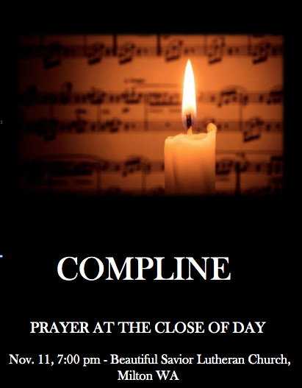

6

October Senior Saints Potluck

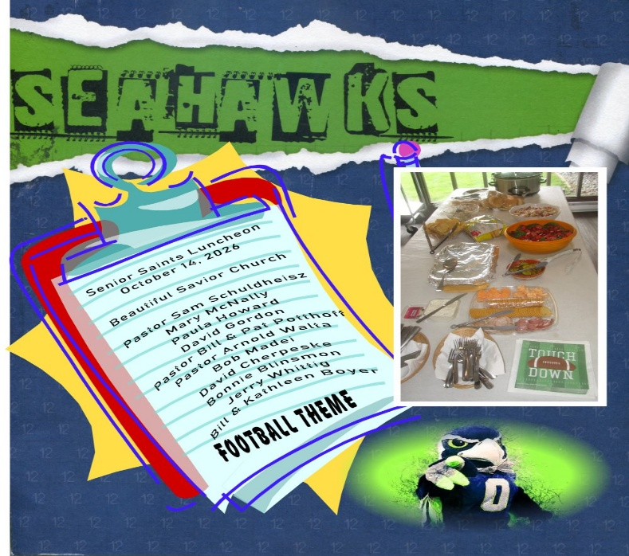

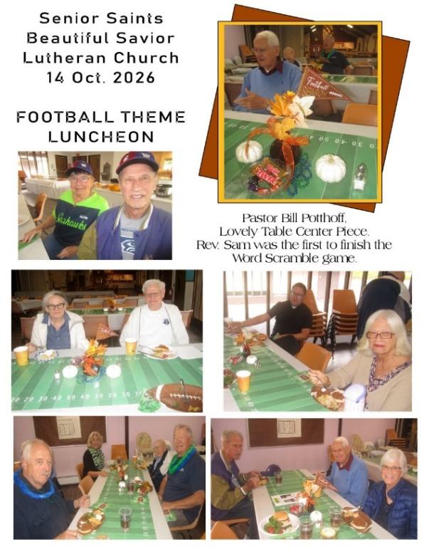
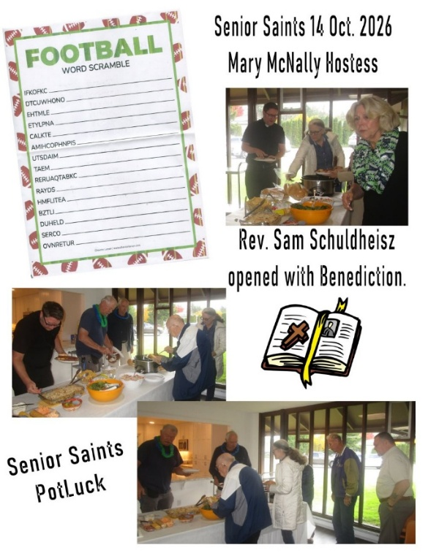

7

SENIOR SAINTS – DECEMBER POTLUCK

Outsmart the Scammers Before They Outsmart You!

Winter is coming, and so are the scammers! If you want to learn about the current financial scams and how to recognize them, please join us December 9 at 1 o’clock (directly following the noon Advent service) for a potluck luncheon and presentation by Chantelle La Marr titled “Outsmart the Scammers”.
Chantelle has addressed many groups in our area on how to recognize and avoid current financial scams. Chantelle La Marr is a Financial Advisor with Edward Jones who is passionate about helping individuals, families and business owners build confident financial futures. Drawing on years of experience in the financial services industry, she specializes in retirement planning, financial education and legacy & wealth management strategies.
So, if you are retired or semi-retired and want to learn how to recognize and avoid falling victim to the latest financial scams making the rounds, please join us on December 9. There will be a sign-up sheet for food posted by the water fountain. Also, if you are willing to help with decorations, set up or clean up, please let either Beth Boyd or Mary McNally (denfmcnally@msn.com) know of your willingness to help.
We hope to see you there for this informative presentation!

Mark your calendars for the South Sound Classical Choir! December 4th, at 7:00 p.m. We look forward to this beautiful concert every December.

8
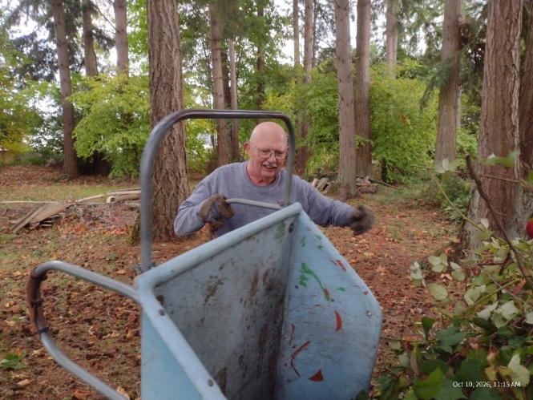
October 10th Trustee’s Work Party
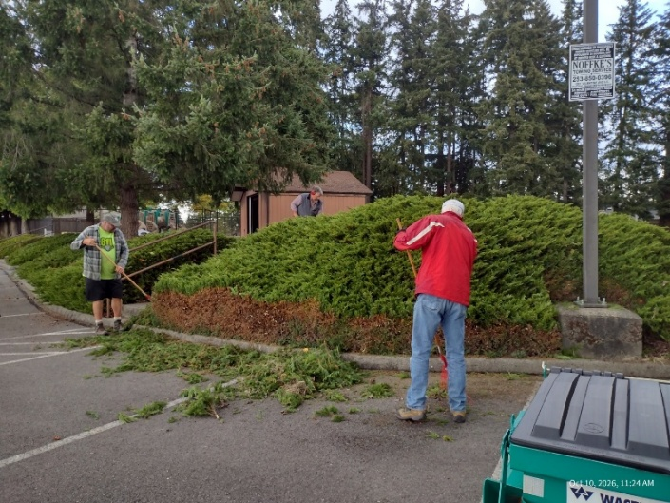

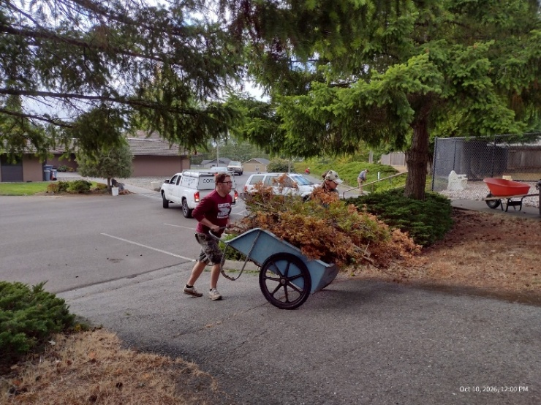
Thank You Trustee’s and all who volunteered to help

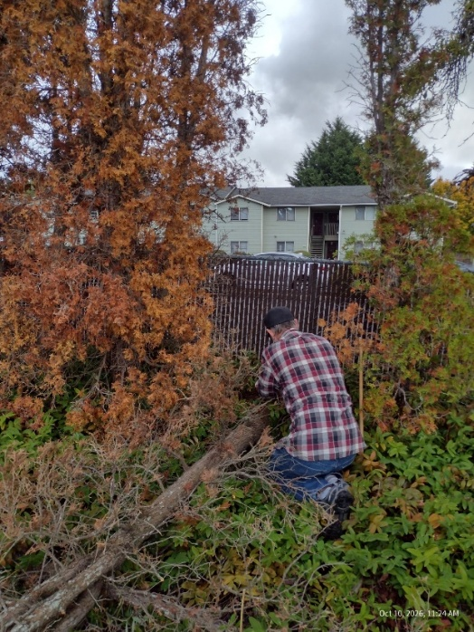
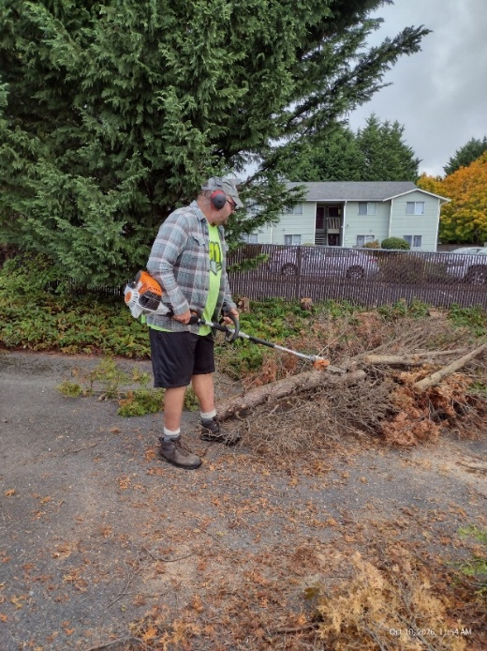
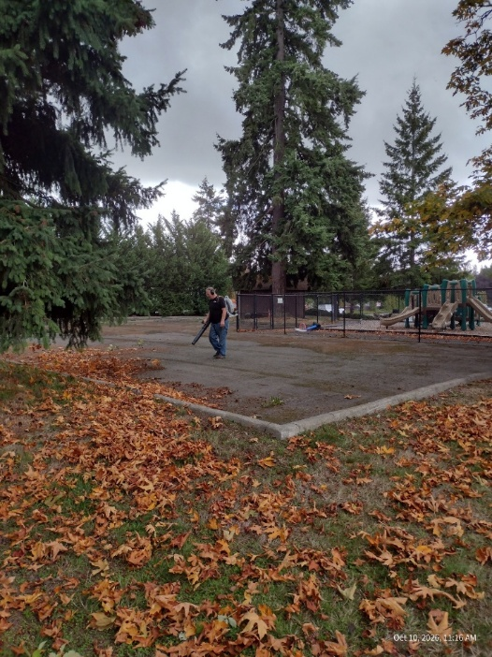

9

10
Born in November
1st – Kathi Boyer
4th – John Lee
4th – Bonnie Blinsmon
10th – Joanne Lund
13th – Mary Mills
15th – Madeline House
15th – Jonathan Motteler
15th Carol Rafael
18th – Jerry Nettnin
20th – Sarah Carlson
22nd – Charles Morehead
23rd – Elizabeth Cook
23rd – Valerie Roemer

Baptized in Christ
2nd – Belinda Bergman
4th – Michaela Perkovich
6th – Henry Jannsen
9th – Reese Galanti
9th – Cosette Galanti
9th – Nicholas Vetter
24th – Joanne Lund
27th – Kimi Jannsen
29th – Elizabeth Cook

November Wedding Anniversaries
8th – Ron & Karen Schlaht
16th – Michael & Jaana Fogt
22nd – Matt & Lynette Perkovich

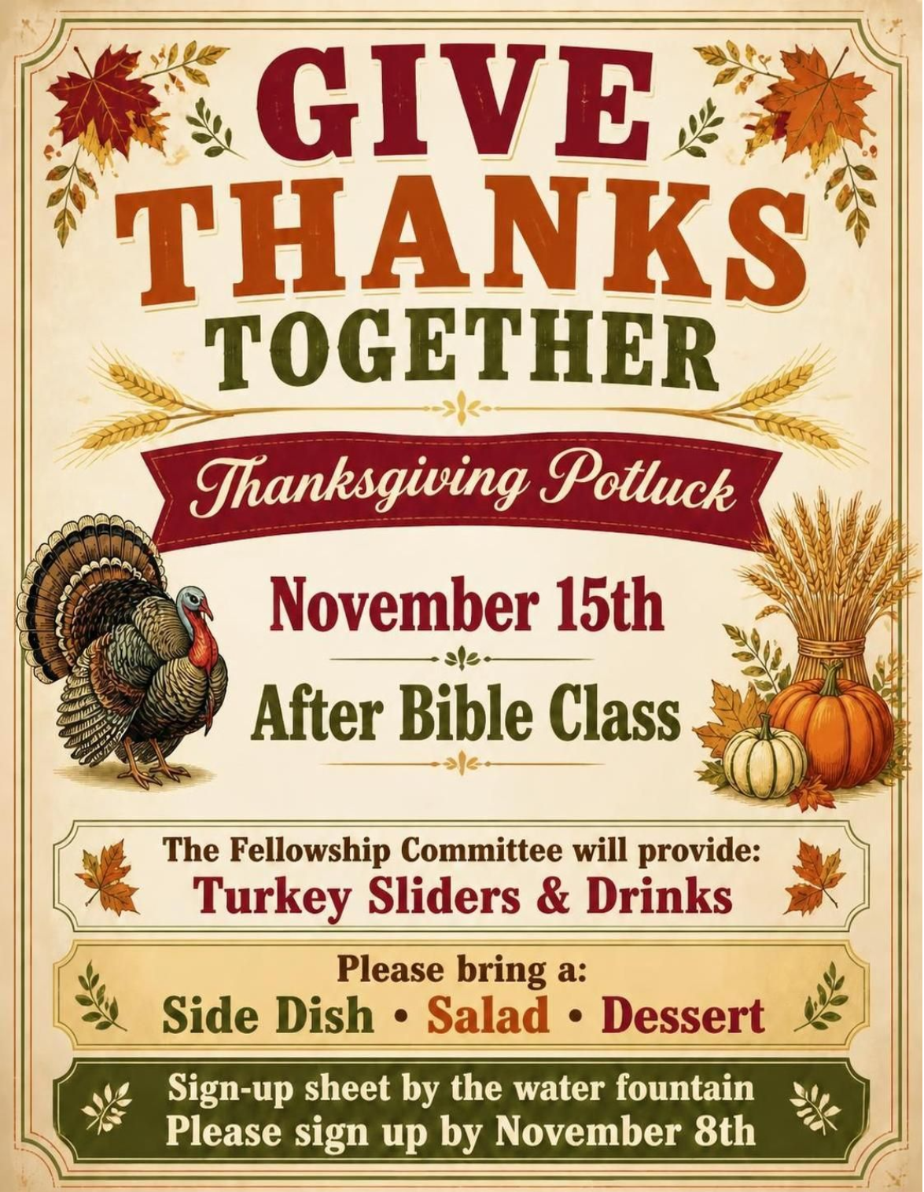
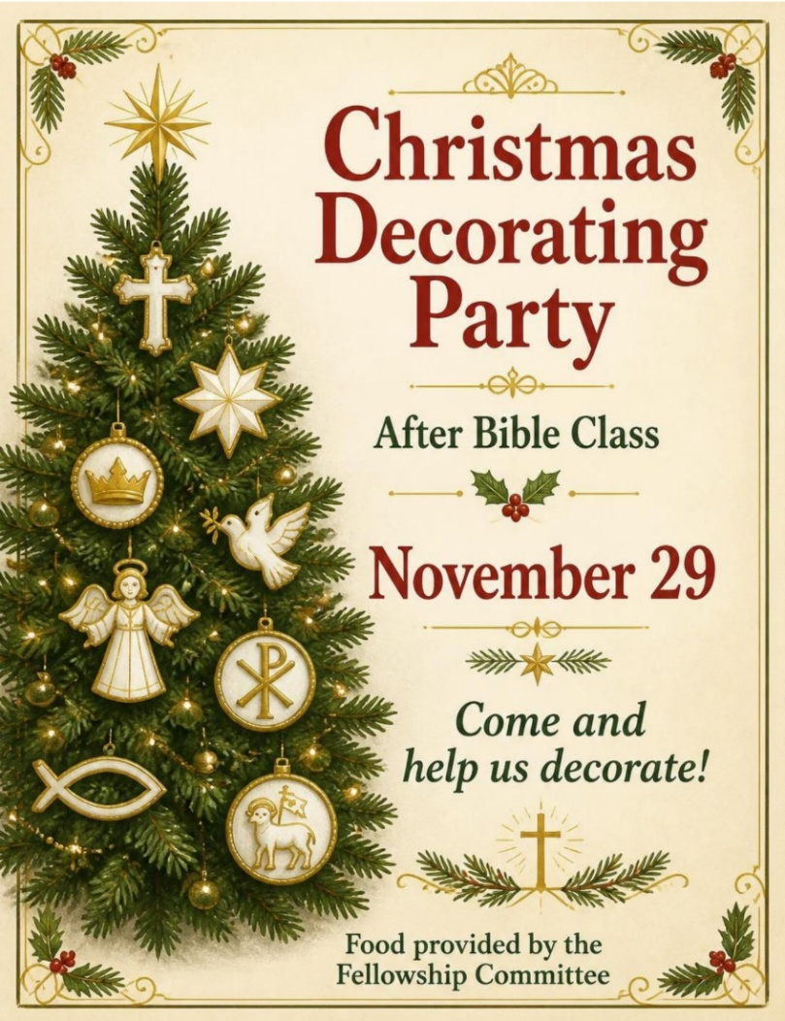

Children’s Christmas Party
December 6th 12:00 – 1:30 pm
Join the fun!!
Lunch, crafts & games
Contact Linda Howard with questions

11

Advent & Christmas Service Schedule
Nov. 29 - 1st Sunday in Advent

Dec. 2 ~ Midweek Advent Svc.
12:00 & 7:00 pm

Dec. 6 - 2nd Sunday in Advent

Dec. 9 ~ Midweek Advent Svc.
12:00 & 7:00 pm

Dec. 13 - 3rd Sunday in Advent

Dec. 16 ~ Midweek Advent Svc.
12:00 & 7:00 pm

Dec. 20 - 4th Sunday in Advent

Dec. 24th ~ Christmas Eve Service
7:00 & 11:00 pm

Dec. 25th ~ Christmas Day Service
10:00 am

Dec. 31st ~ New Year’s Eve. Svc.
7:00 pm

November 2026
Sun |  | Mon |  | Tue |  | Wed |  | Thu |  | Fri |  | Sat
1  D.S. III  9:30 a.m.  Sunday School  11:00 a.m. |  | 2 |  | 3  10:00 a.m.  Women’s Bible Study  *6:30 Elders Mtg.  *7:00 Trustees Mtg. |  | 4 |  | 5 |  | 6  Office closed |  | 7
8  D.S. III  9:30 a.m.  Sunday School  11:00 a.m. |  | 9 |  | 10  10:00 a.m.  Women’s Bible Study |  | 11  7:00 p.m. Compline Service  Office Closed |  | 12 |  | 13  Office closed |  | 14  8:00 a.m. Men’s Bible Study
15  D.S. III  9:30 a.m.  Sunday School  11:00 a.m.  *12:00 Thanksgiving Potluck |  | 16 |  | 17  10:00 a.m.  Women’s Bible Study |  | 18 |  | 19 |  | 20  Office closed |  | 21
22  D.S. III  9:30 a.m.  Sunday School  11:00 a.m. |  | 23 |  | 24  10:00 a.m.  Women’s Bible Study |  | 25 |  | 26  10:00 a.m. Thanksgiving Day Service  Office Closed |  | 27  Office closed |  | 28
29  D.S. III  9:30 a.m.  Sunday School  11:00 a.m.  *12:00 Church Decorating |  | 30

